DL Lab 09

IT21264016

Part 01

PART 02

Question 01

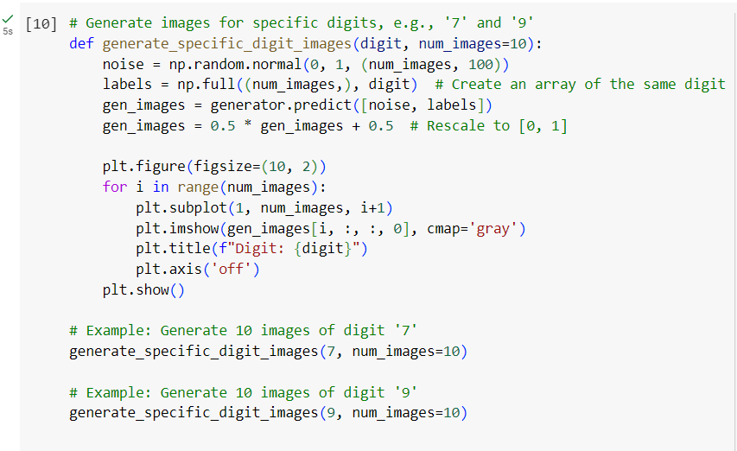

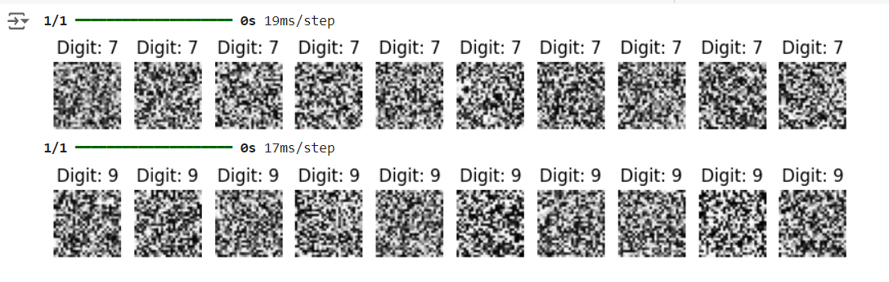

Question 02

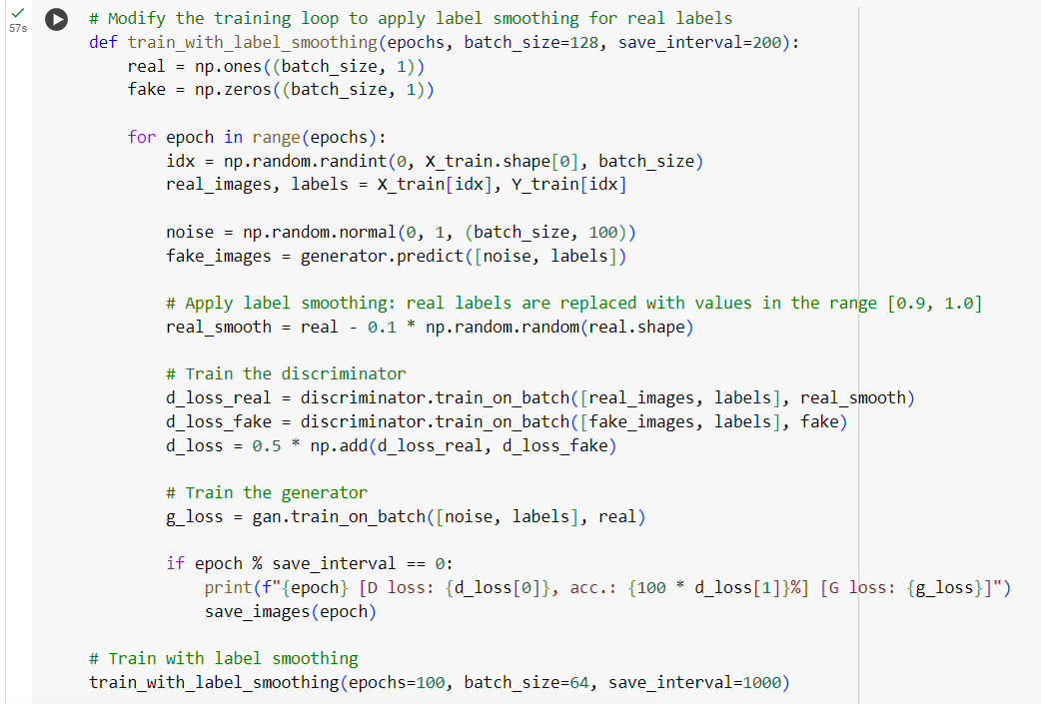

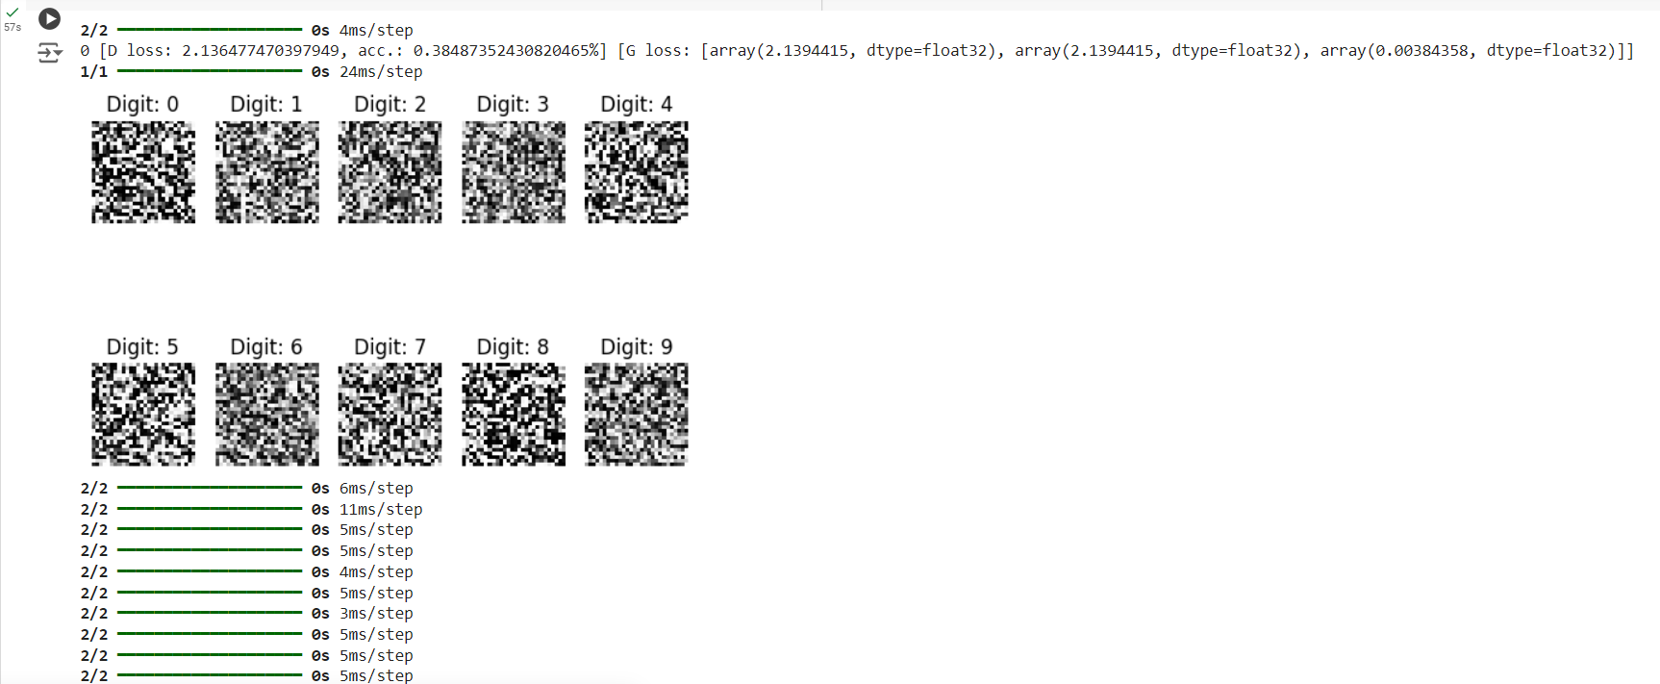

Question 03

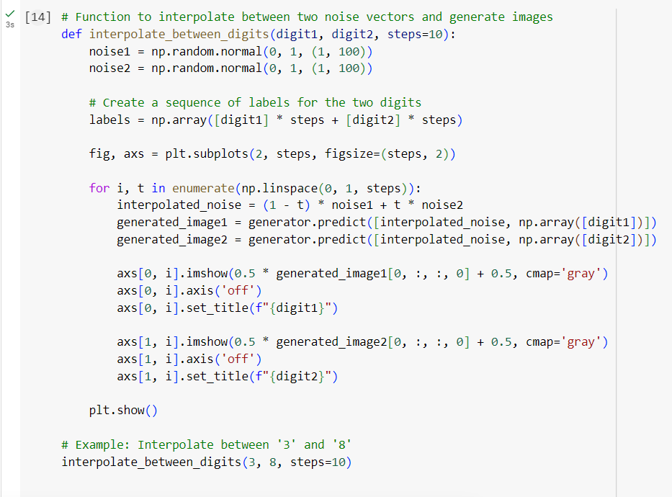

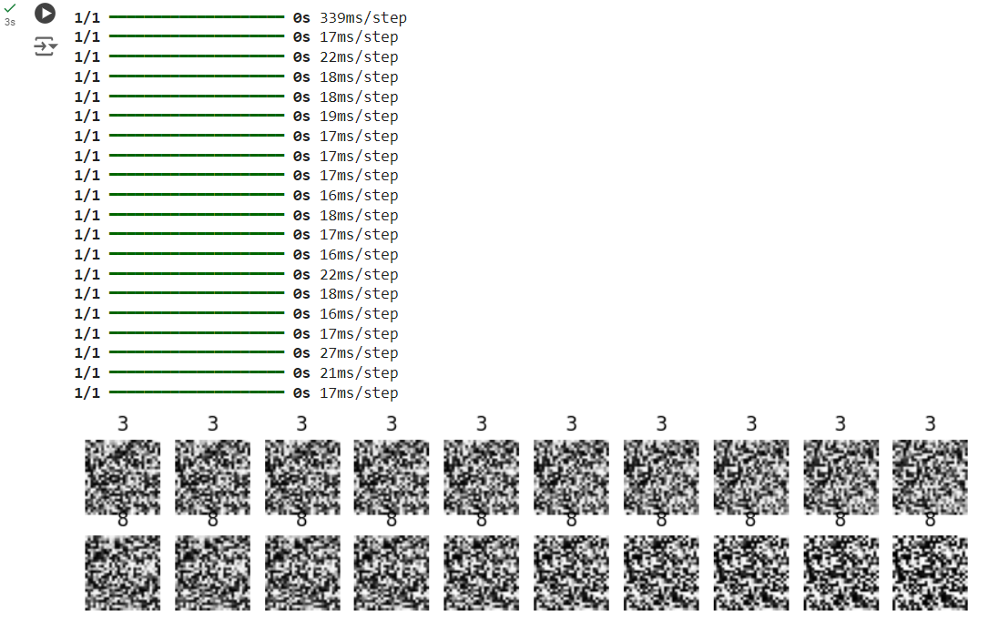

# PART 03

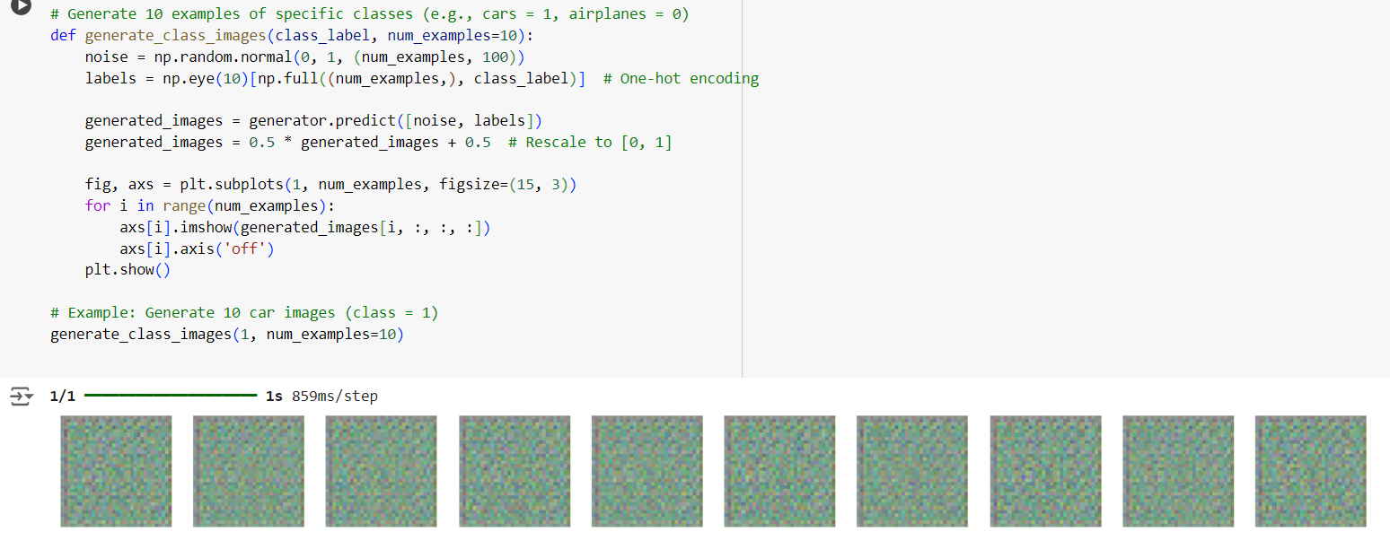Question 1

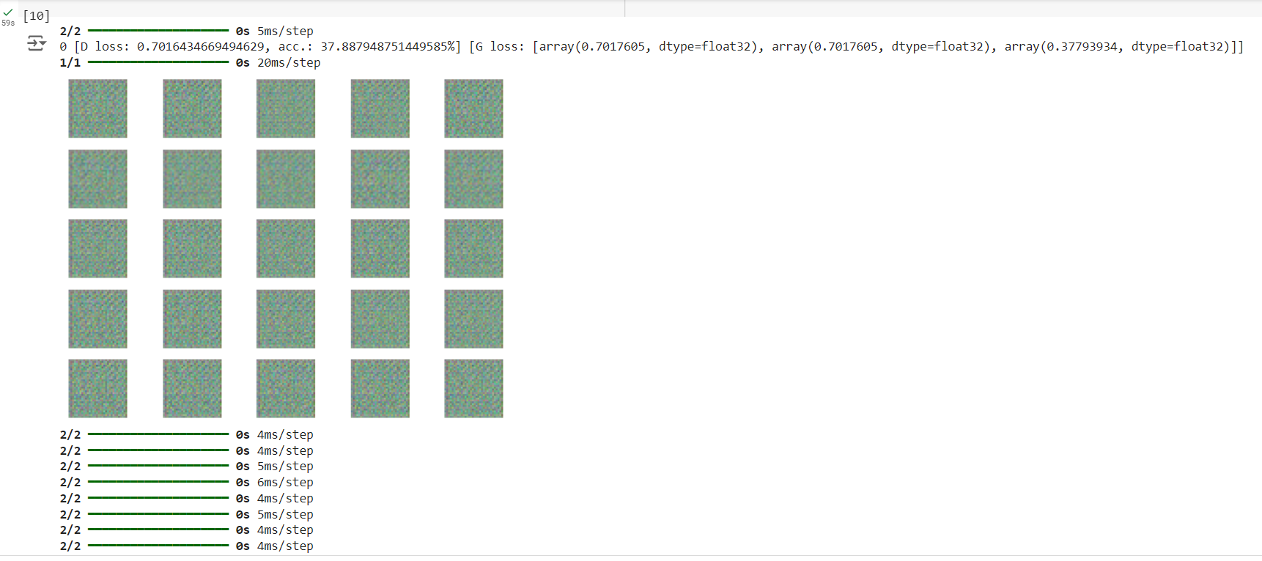Question 2

Question 3

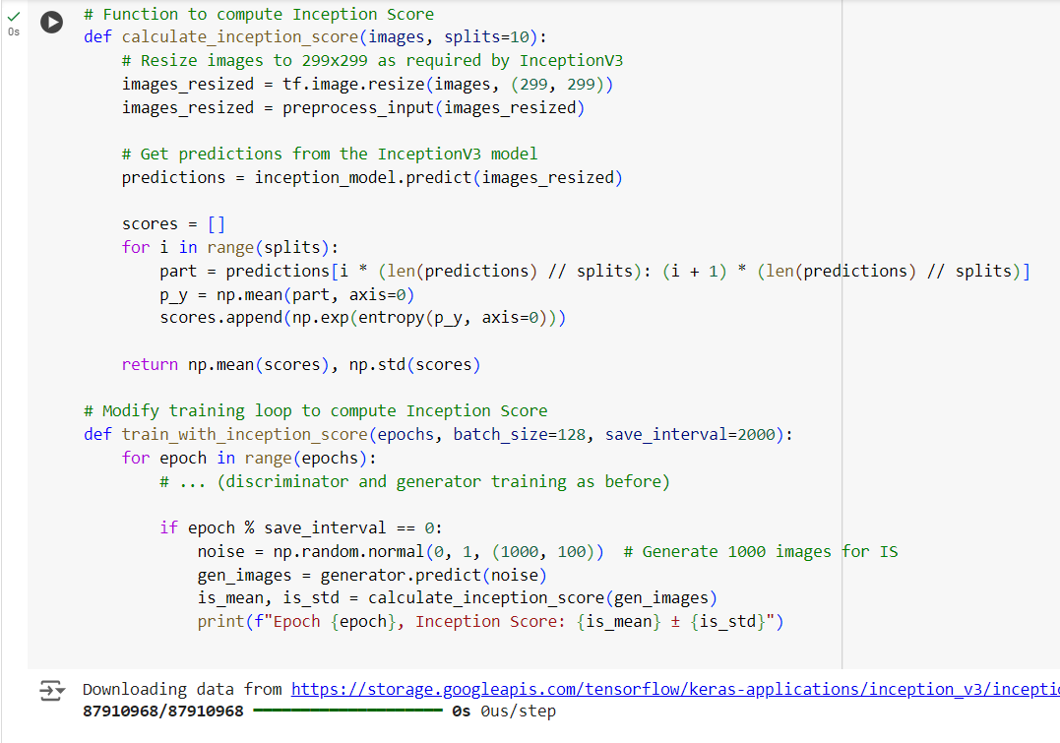

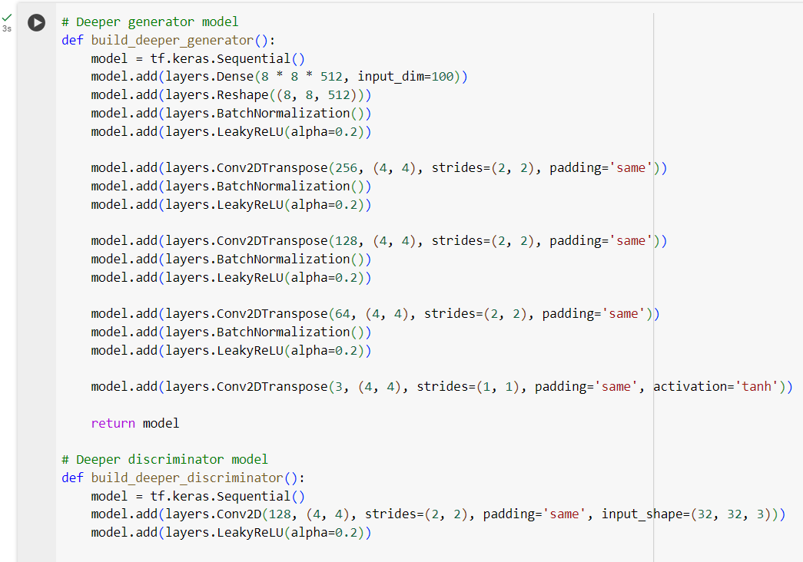Question 4

**Impact of Parameter Changes**

Expanding the latent space dimension enables the model to learn more intricate features, often enhancing both image variety and detail. However, an excessively large latent space might hinder training, resulting in noisier or less coherent outputs.

Using optimizers like Adam with varying learning rates (e.g., 0.0002) can significantly affect training stability. Lower learning rates generally promote more stable training and gradual improvements, while higher rates may speed up convergence but increase the risk of instability.

Smaller batch sizes (such as 32) can lead to noisier gradients and unstable training, though they may encourage the model to capture a wider range of features. On the other hand, larger batch sizes (like 128) tend to result in smoother learning but could overfit or demand more computational power.

**Quality and Range of Generated Images**

As training progresses, generated images typically become sharper and more detailed, particularly when the GAN is properly fine-tuned. Early epochs often produce blurry outputs, whereas later ones generate more realistic images.

Only overly complex models or unstable training can lead to mode collapse, where the generator consistently produces nearly identical images.

The diversity of generated images is largely influenced by the latent space configuration. With proper tuning, the model can generate a wide array of objects and styles within the given class. A smaller latent space or poorly tuned settings may result in repetitive outputs, reducing the variety of the generated images.